**Git– Question & Answers**

**Git Fundamentals:**Question 1:What is the purpose of the git ‘init’ command, and when should it be used?

The ‘git init’ command is used to create a new, empty Git repository in a directory. It initializes the directory as a Git repository by creating a hidden ‘.git’ folder, which stores all the metadata and version control information for the project.

**Purpose of the git init Command**

The git init command is used to create a new, empty Git repository in a directory. It initializes the directory as a Git repository by creating a hidden .git folder, which stores all the metadata and version control information for the project.

**Key Functions of git init**

1. **Initialize a Repository:**
   * Creates a new Git repository in the current directory or a specified directory.
   * Establishes the foundation for tracking changes in the project files.
2. **Reinitialize an Existing Repository:**
   * Can be used to reinitialize an existing repository if the .git folder is accidentally deleted or corrupted.
3. **Set Up Bare Repositories:**
   * Can initialize a "bare" repository, which is used as a central repository for collaboration, without a working directory.
   * Example: git init --bare.

**When Should git init Be Used?**

1. **Starting a New Project:**
   * When beginning a new project and you want to use Git for version control.

Example:  
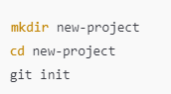

2. **Turning an Existing Project into a Repository:**

* If you already have a directory with project files and want to start tracking them with Git.

Example:  
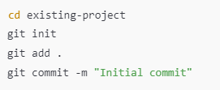

Question 2:What is the difference between ‘git add.’ and ‘git add -A’?  
Provide an example of when you would use each.

Both commands stage changes to the Git index (staging area) but differ in **scope** and **behavior** regarding tracked and untracked files.

**1. git add .**

* **Scope:**
  + Adds all **new** and **modified** files in the current directory and its subdirectories to the staging area.
  + Does **not** stage deleted files outside the current directory unless explicitly mentioned.
* **Behavior:**
  + Operates **relative to the current directory** where the command is executed.
  + Ignores deleted files that are not in the current directory.
* **Use Case:**
  + When you want to stage only the files that have been added or modified within a specific directory without affecting deletions outside it.

**2. git add -A**

* **Scope:**
  + Stages **all changes** in the repository, including:
    - New files
    - Modified files
    - Deleted files
* **Behavior:**
  + Operates **globally across the entire repository**, regardless of the current directory.
  + Ensures that all tracked and untracked files, as well as deletions, are staged.
* **Use Case:**
  + When you want to stage every change across the entire repository, including deletions, for a comprehensive commit.

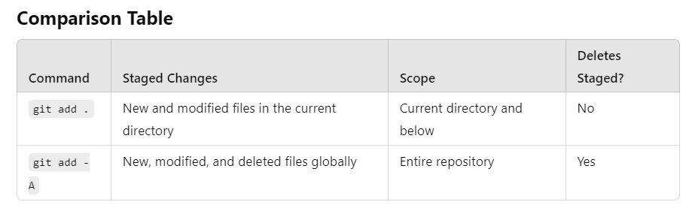

**When to Use Each Command**

**git add .**

* **Scenario:**
  + You are working in a specific directory and want to stage only the changes within that directory.
* **Example Use Case:**
  + You're updating multiple files in a subproject but don't want to accidentally stage unrelated deletions or changes elsewhere.

**git add -A**

* **Scenario:**
  + You want to stage all changes in the repository, including new files, modifications, and deletions, regardless of the current directory.
* **Example Use Case:**
  + Before making a commit for a global update or cleanup operation, ensuring all changes are included.

**Practical Tip**

* If unsure, use git status to review changes before staging. This helps you decide whether to use git add . or git add -A based on the scope of changes you want to include in your commit.

Question 3:How do you commit changes with a meaningful commit message using Git?  
Provide an example.

**Committing Changes with a Meaningful Commit Message in Git**

Committing changes in Git involves capturing the current state of your project in a snapshot. A meaningful commit message helps explain what was changed and why, making the repository history easier to understand for collaborators (and your future self!).

1**. Stage Changes:**

* Add files to the staging area using git add or git add -A.

2. **Commit Changes with a Message:**

* Use the git commit -m "Your meaningful commit message" command.



3. **Write Descriptive Commit Messages:**

* A good commit message should:
  + Be concise but informative.
  + Use imperative mood (e.g., "Fix bug" instead of "Fixed bug").
  + Describe **what** and **why**, not just **how**.

**Example of a Meaningful Commit Message**

**Good Example:**



What: Fixes how login errors are handled.

Why: To ensure users see clear and friendly error messages.

**Poor Example:  
**

**Git Branching and Merging:**  
Question 1:What is the purpose of creating a new branch in Git, and how do you create one?

In Git, a branch is a pointer to a specific commit in the repository. Branching allows you to work on a separate line of development without affecting the main codebase. It is especially useful for:

1. Isolating Changes:
   * You can develop new features, fix bugs, or experiment with changes without interfering with the main branch (usually main or master).
2. Collaborative Development:
   * Each developer can work on their branch independently, and changes can be merged into the main branch after review.
3. Safe Code Management:
   * Reduces the risk of breaking the main branch while testing or developing new ideas.
4. Organizing Workflow:
   * Helps maintain a clean and logical commit history by keeping unrelated changes in separate branches.

**How to Create a New Branch in Git**

**1. Create a New Branch**

**Example:**



**2. Create and Switch to a New Branch**

Use the git checkout command (older versions) or the more modern git switch: